Regulatory Committee
Meeting to be held on 26th January 2022

Part I

Electoral Division affected:
Lancaster Rural North

Wildlife and Countryside Act 1981
Definitive Map Modification Order Investigation
Addition of Footpath along Hobson's Lane, Over Kellet
(Annex ‘A’ refers)

Contact for further information quoting reference number 804-678:
Simon Moore, 01772 531280, Paralegal Officer, County Secretary and Solicitors Group, Simon.Moore@lancashire.gov.uk
Jayne Elliott, 01772 537663, Public Rights of Way Definitive Map Officer, Planning and Environment Group, jayne.elliott@lancashire.gov.uk

Brief Summary

Application for the addition to the Definitive Map and Statement of Public Rights of Way of a Footpath along Hobson's Lane, Over Kellet.

Recommendation

That the application for the addition on the Definitive Map and Statement of Public Rights of Way of a Footpath from the junction of Borron Lane U18835 and Capernwray Road U18835 along Hobson's Lane to a junction with 1-24-FP15 be not accepted.

Detail

An application under Schedule 14 of the Wildlife and Countryside Act 1981 has been received for the addition to the Definitive Map and Statement of Public Rights of Way of a Footpath from the junction of Borron Lane U18835 and Capernwray Road U18835 along Hobson's Lane to a junction with 1-24-FP15.

The county council is required by law to investigate the evidence and make a decision based on that evidence as to whether a public right of way exists, and if so its status. Section 53(3)(b) and (c) of the Wildlife and Countryside Act 1981 set out the tests that need to be met when reaching a decision; also current Case Law needs to be applied.

An order will only be made to add a public right of way to the Definitive Map and Statement if the evidence shows that:
- A right of way “subsists” or is “reasonably alleged to subsist”

An order for adding a way to or upgrading a way shown on the Definitive Map and Statement will be made if the evidence shows that:
- “the expiration… of any period such that the enjoyment by the public…raises a presumption that the way has been dedicated as a public path or restricted byway”

When considering evidence, if it is shown that a highway existed then highway rights continue to exist (“once a highway, always a highway”) even if a route has since become disused or obstructed unless a legal order stopping up or diverting the rights has been made. Section 53 of the Wildlife and Countryside Act 1981 makes it clear that considerations such as suitability, the security of properties and the wishes of adjacent landowners cannot be considered. The Planning Inspectorate’s website also gives guidance about the interpretation of evidence.

The county council’s decision will be based on the interpretation of the evidence discovered by officers and documents and other evidence supplied by the applicant, landowners, consultees and other interested parties produced to the County Council before the date of the decision. Each piece of evidence will be tested and the evidence overall weighed on the balance of probabilities. It is possible that the council’s decision may be different from the status given in any original application. The decision may be that the routes have public rights as a footpath, bridleway, restricted byway or byway open to all traffic, or that no such right of way exists. The decision may also be that the routes to be added or deleted vary in length or location from those that were originally considered.

Consultations

Lancaster City Council

Lancaster City Council provided no response to consultation.

Over Kellet Parish Council

Over Kellet Parish Council provided no response to consultation.

Applicant/Landowners/Supporters/Objectors

The evidence submitted by the applicant/landowners/supporters/objectors and observations on those comments are included in Advice – Head of Service – Legal and Democratic Services Observations.

Advice

Head of Service – Planning and Environment

Points annotated on the attached Committee plan.

Point | Grid Reference (SD) | Description
A | 5382 7184 | Open junction of Hobson's Lane (the application route) with Borron Lane and Capernwray Road
B | 5398 7167 | Junction with 1-24-FP 15
C | 5400 7164 | Point on 1-24-FP 15 at which the original route of the footpath crossed Hobson's Lane

Description of Route

A site inspection was carried out in September 2021.

The application route is shown on the attached plan by a thick dashed line between point A and point B. Also marked on the Committee plan – and referred to in the map and documentary evidence below - is point C.

In 2007 the route originally recorded as 1-24-FP 15 was diverted under a legal process. As a result that part of Hobson's Lane from point C to point B is recorded as a public footpath and is therefore not included as part of the application route.

The applicant did not submit any modern user evidence in support of the application and so the relevance of point C in considering the history of the route is important as prior to 2007 the basis of the application was that use was made of the route A-B-C to link to the footpath recorded as 1-24-FP 15 prior to it being legally diverted onto part of Hobson's Lane.

At point A the public vehicular road changes name from Capernwray road to Borron Lane at the junction with the application route – known as Hobson's Lane.

From point A the route extends in a south easterly direction. The junction with the public vehicular road is wide and unrestricted. Access onto the application route is along a tarmac road. The road is 9 metres wide at point A bounded by well maintained stone walls on either side.

The full width is tarmacked but it appears that the original route had been widened and on examination of older maps it is evident that the application route extends only along the north eastern half of the tarmac road to a width of approximately 5 metres – as indicated by a slight change in the tarmac.

After approximately 30 metres the tarmac road splits with a wall running centrally. The application route follows the tarmac road along the north east side of the wall whilst an access road leading directly to Hobson's House runs parallel but on the south west side of the wall.

The application route provides access to Capernwray House Farm, including a large number of industrial/farm buildings located immediately north of the route, continuing as a tarmac road through to point B.

At point B a wooden stile is located in the hedge on the south west side of the application route which is waymarked as part of 1-24-FP 15. From point B the route of 1-24-FP 15 continues along Hobson's Lane to point C where it is crossed by a large wooden gate with gap sufficient for pedestrians to pass through as it enters a caravan park. The route between B and point C appears not to be used as vehicular access to the caravan park or to Hobson's House – although it would be wide enough to sustain such use.

The total length of the application route (A-B) is 240 metres.

Map and Documentary Evidence

A variety of maps, plans and other documents were examined to discover when the route came into being, and to try to determine what its status may be.

Document Title | Date | Brief Description of Document & Nature of Evidence
Yates’ Map  of Lancashire | 1786 | Small scale commercial map. Such maps were on sale to the public and hence to be of use to their customers the routes shown had to be available for the public to use. However, they were privately produced without a known system of consultation or checking. Limitations of scale also limited the routes that could be shown.
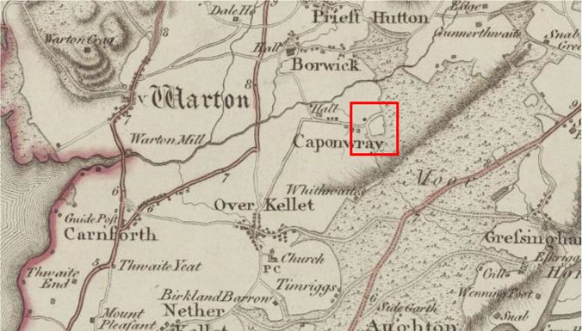
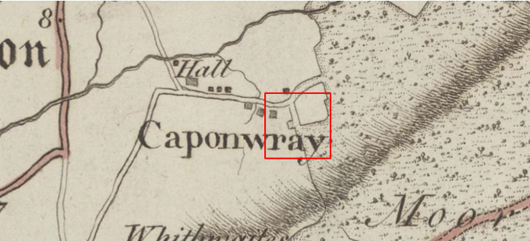
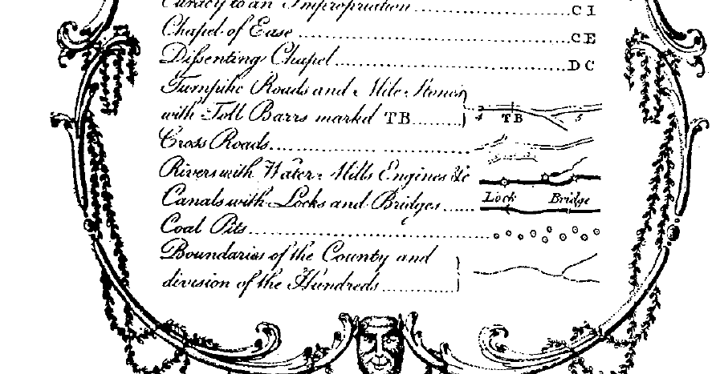
Observations |  | A route consistent with the application route is shown extending from Borron Lane at point A to provide access to an area of moorland. The route is shown as a cross-road although it is noted in this instance that it is not shown as a through route but provides access to a large area of moorland instead. No building (Hobson House) is shown but there is a square area of land shown immediately to the west of the route at its southern end which may have been where the property was located.
Investigating Officer's Comments |  | The application route existed in 1786.  It is not known what is meant by the term 'cross road' but the only other category of highway shown on the map is turnpike roads. The route did not form part of a through route so although access may have been the route may have been used by a limited number of people who required access to the moor.
Over Kellet Inclosure Act Award and Maps  CRO Ref: AE/5/9 | 1805 | Inclosure Awards are legal documents made under private acts of Parliament or general acts (post 1801) for reforming medieval farming practices, and also enabled new rights of way layouts in a parish to be made. They can provide conclusive evidence of status.  Over Kellet Moor was enclosed by a private act of parliament dated 1779 (volume 2). The Inclosure Award is available to view at the CRO (Ref: AE/5/9) and is dated 1805.
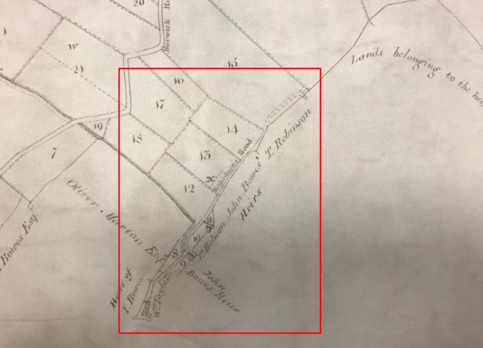

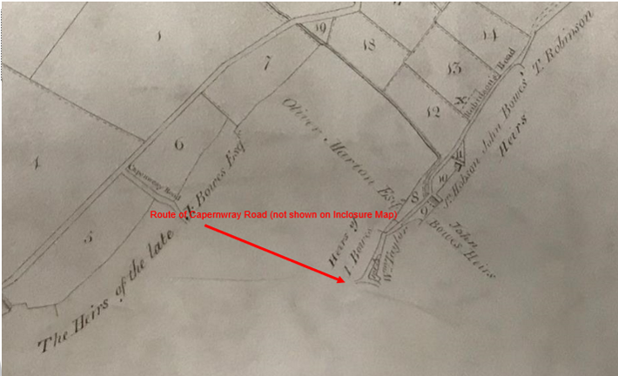

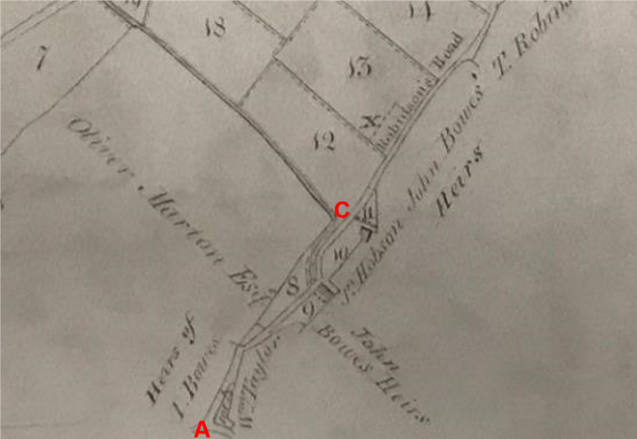

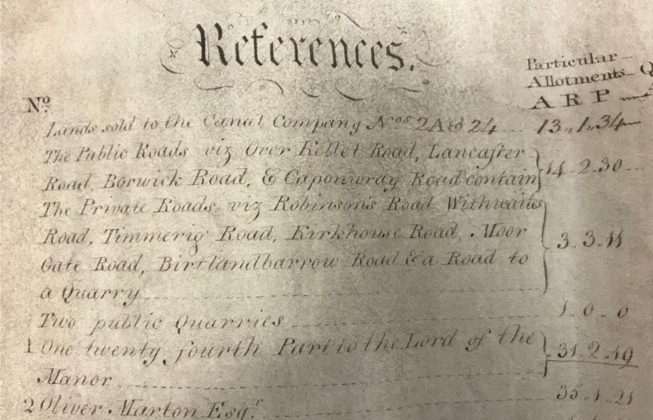
The Inclosure Award map shows the area over which the application route runs although it is clear that the land to be inclosed is largely to the east of the route.
A route consistent with the application route is shown from point A extending from the junction with Capernwray Road to point C where an unnamed building is shown adjacent to the route which approximates to the location of Hobson's House (point C). The route between point A and point C is shown to zig zag between plots numbered 8, 9 and 10 - all of which are listed on the Map as having been inclosed and Awarded to private individuals.
Beyond point C the route is shown to continue and is named as Robinson's Road (it is not clear whether this name also applied to the application route) providing access to two plots inclosed as part of the process (allotments 15 and 30) and to land outside the remit of the inclosure which is marked on the map as being owned by the Heirs of J Barrow Esq.
Robinson's Road is described on the Inclosure Map as a Private Road and is described in the same way in the Inclosure Award which specifically refers to the creation of a private road to be known as Robinson's Road and set out at a width of 20 feet. The route is described as starting at the junction with Capernwray Road and running in a south easterly direction on the west side of allotments 8, 12, 13 and 14 and over the south west end of allotment 15.
A route largely consistent with the application route from point A appears to have been acknowledged – or possibly created - as part of the inclosure process as access to allotments and to land outside the remit of the inclosure Award. It is named on the map as Robinson's Road and specified as being a private road.
A building consistent with the location of Hobson's House is shown and there is reference to a landowner named Jonathon Hobson on the map which may explain the origins of the name 'Hobson House' and 'Hobson Lane'. It also appears apparent that the route named as Robinson's Road would have provided access to land not affected by the Inclosure suggesting that the route may – at least in part – have existed prior to the Inclosure process being carried out – particularly as the start of the route from point A is shown on Yate's Map published in 1786. The application route does not however appear to have been considered to be a public route at that time.
Greenwood’s Map of Lancashire | 1818 | Small scale commercial map. In contrast to other map makers of the era Greenwood stated in the legend that this map showed private as well as public roads and the two were not differentiated between within the key panel.
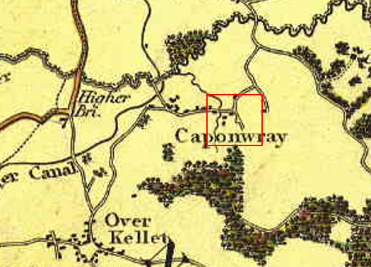
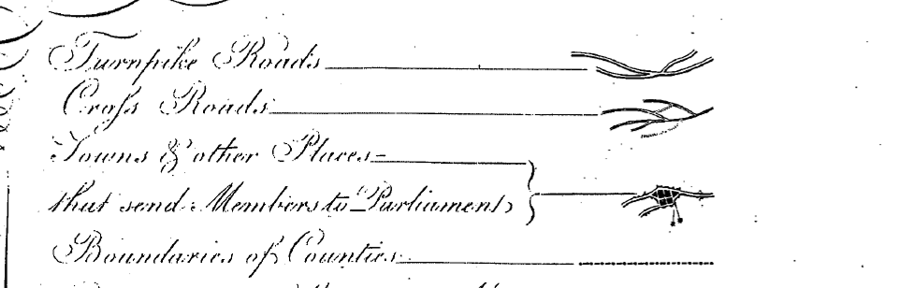
Observations |  | The application route is shown as a cross road providing access to an open area of land. It appears to have been extended since it was originally shown on Yates' map which is consistent with how it was shown on the Inclosure Plan.
Investigating Officer's Comments |  | The application route existed in 1818 providing access onto an open area of land. Greenwood was known to record both public and private routes and in this instance the route is shown leading directly onto land – not as a through route – so its inclusion on the map does not indicate that the route was necessarily considered to be a public one.
Hennet's Map of Lancashire | 1830 | Small scale commercial map. In 1830 Henry Teesdale of London published George Hennet's Map of Lancashire surveyed in 1828-1829 at a scale of 71/2 inches to 1 mile. Hennet's finer hachuring was no more successful than Greenwood's in portraying Lancashire's hills and valleys but his mapping of the county's communications network was generally considered to be the clearest and most helpful that had yet been achieved.
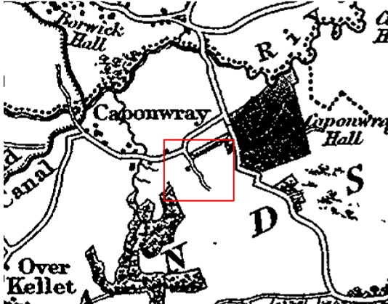
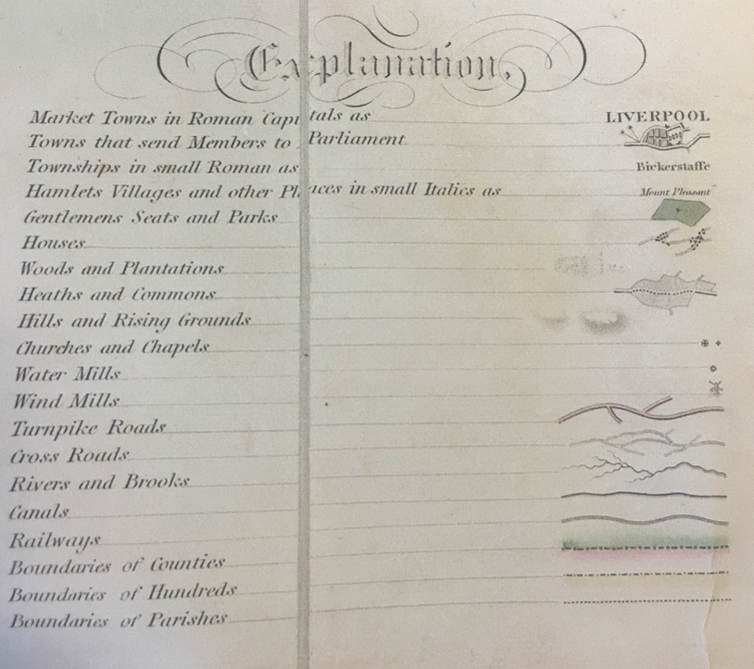
Observations |  | The application route is shown providing access to and past Hobson House – which is shown but not named on the map. The route is shown as a cross road leading onto an open area of land.
Investigating Officer's Comments |  | The application route existed as a substantial route in 1830 providing access to a property and to an open area of land. It is shown as a cross road but it is not fully known what is meant by this term. As the only other category of 'road' shown on the map are turnpike roads, it is possible that a cross road was regarded as either a public minor cart road or a bridleway (as suggested by the judge in Hollins v Oldham).  Hollins v Oldham Manchester High Court (1995) [C94/0205] Judge Howarth examined various maps from 1777-1830 including Greenwoods, Bryants and Burdetts. Maps of this type, which showed cross roads and turnpikes, were maps for the benefit of wealthy people and were very expensive. There was “no point showing a road to a purchaser if he did not have the right to use it.”  It is unlikely that a map of this scale would show footpaths so if a footpath – or footpaths existed as a continuation of the road, or leading off it they were not likely to be shown.
Canal and Railway Acts |  | Canals and railways were the vital infrastructure for a modernising economy and hence, like motorways and high speed rail links today, legislation enabled these to be built by compulsion where agreement couldn't be reached. It was important to get the details right by making provision for any public rights of way to avoid objections but not to provide expensive crossings unless they really were public rights of way. This information is also often available for proposed canals and railways which were never built.
Observations |  | The land crossed by the application route was not affected by any existing or proposed canals.
Investigating Officer's Comments |  | No inference can be drawn with regards to the existence of public rights.
Tithe Map and Tithe Award or Apportionment | 1840 | Maps and other documents were produced under the Tithe Commutation Act of 1836 to record land capable of producing a crop and what each landowner should pay in lieu of tithes to the church. The maps are usually detailed large scale maps of a parish and while they were not produced specifically to show roads or public rights of way, the maps do show roads quite accurately and can provide useful supporting evidence (in conjunction with the written tithe award) and additional information from which the status of ways may be inferred.
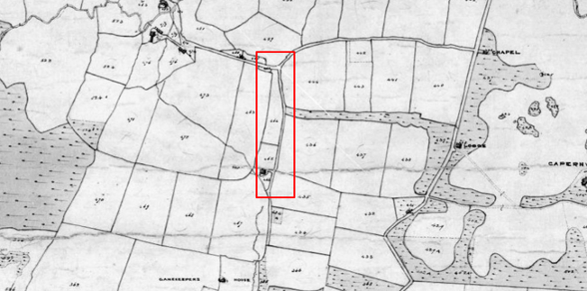
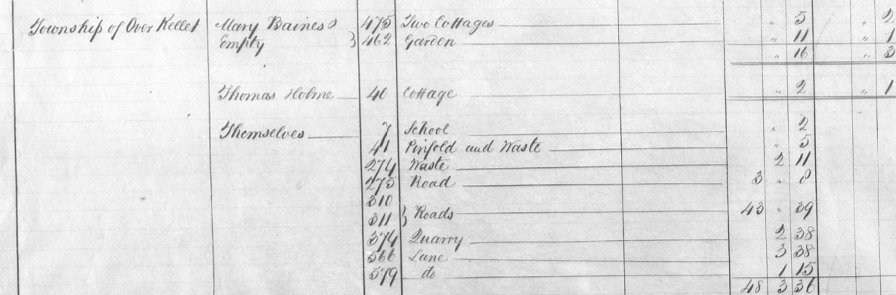
Observations |  | The application route is shown as part of a longer bounded route which provides access to Hobson House (plot 466 – owned by James Park and occupied by John Cannon) and to land at the south end of the road which was owned and occupied by George Marton Esq.  The road – including the application route – is not numbered.  An examination of the Tithe Map as a whole shows that a significant number of roads known to carry public rights are not numbered although a few are and the Tithe Award specifies them as being in the ownership of the Township with no tithes payable.
Investigating Officer's Comments |  | The application route existed as part of a longer route providing access to Hobsons House and land in private ownership. Access may have been available to the public but there is no indication that any through routes – on foot or otherwise, existed at that time.
6 Inch Ordnance Survey (OS) Map  Sheet 25 (XXV) | 1847 | The earliest Ordnance Survey 6 inch map for this area surveyed in 1844-45 and published in 1847.
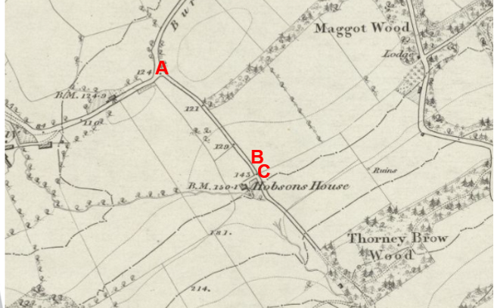
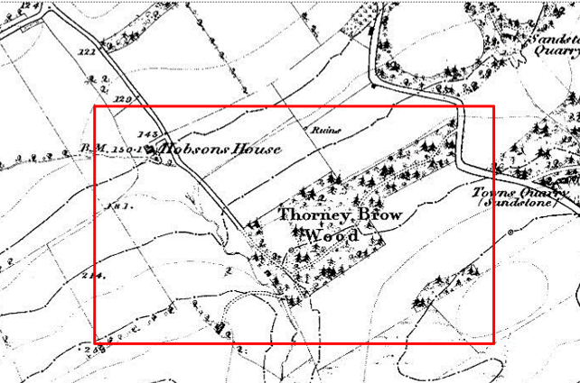
Observations |  | The application route is shown on the map as part of a longer bounded route providing access to Hobson's House and continuing south east to provide access to Thorney Brow Wood and to an un-named building (identified as the Game Keeper's Tower on later editions of the map). An unfenced track is shown passing through the wood leading to Borwick Road.
Investigating Officer's Comments |  | The application route existed in 1844-45 as part of a longer route which, for the first time, is shown as a through route connecting to Borwick Road as well as providing access to properties and land.  The route appears to have been capable of being used – at least on foot.
Cassini Map Old Series |  | The Cassini publishing company produced maps based on Ordnance Survey mapping. These maps have been enlarged and reproduced to match the modern day 1:50,000 OS Landranger Maps and are readily available to purchase.
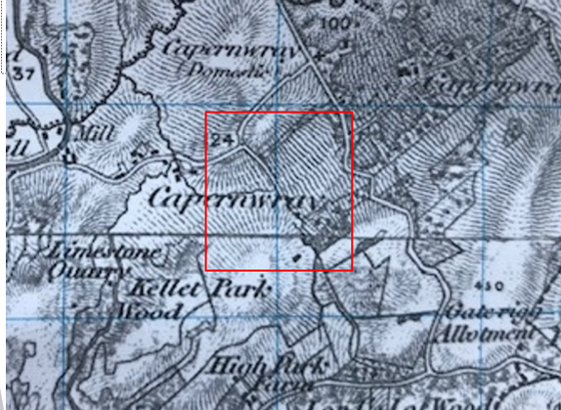
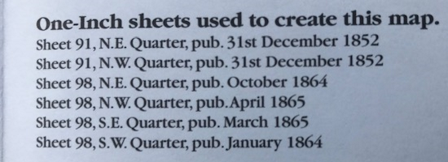
Observations |  | The application route is shown on the map as part of a longer substantial route. The route is shown extending as far as some woodland but no through route is shown.
Investigating Officer's Comments |  | The original scale of the map (1 inch to the mile) means that only the more significant routes are generally shown. The purpose of the map in the late 1800s would probably have been to assist the travelling public on horseback or vehicle suggesting that the through roads shown had public rights for those travellers.  Whilst the application route is shown – suggesting that it would be capable of being used – it is not shown as a through route suggesting there may have been little or no public use made of it. Footpath are not generally shown on a map of this scale so it is necessary to look at a larger scale map (for example the 6 inch OS detailed above) to see whether any other routes connecting to the application route existed.
25 Inch OS Map  Sheet XXV.2 | 1891 | The earliest OS map at a scale of 25 inch to the mile. Surveyed in 1890 and published in 1891.
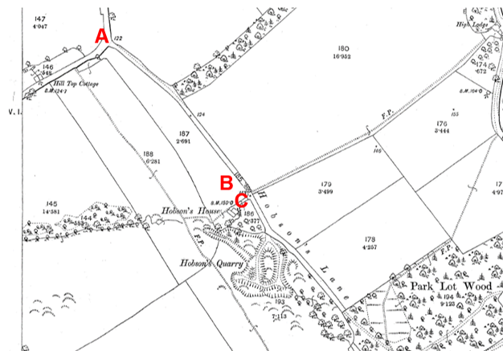
Observations |  | The application route is shown on the map as a substantial bounded route providing access to Hobson's House, Hobson's Quarry and Park Lot Wood.  The route is not gated at point A and access onto it appears to be available. Beyond point C the route is named as Hobson's Lane through to the gated access into Park Lot Wood. The full length of the bounded route from point A through to the gate into Park Lot Wood has one Parcel number and acreage.  Of significance is the fact that a number of routes labelled as footpaths are shown on the map. A footpath is shown running parallel to the application route/Hobson's Lane from Borron Lane to a point to the west of Hobson's Lane where it meets a footpath which started further east at High Lodge on Borwick Road, crosses Hobson's Lane at point C and then continues past Hobson's House through to a junction with the footpath from Borron Lane. A further footpath is shown from that junction continuing south south east to the Game Keeper's tower and then east through Park Lot Wood where a number of routes are shown continuing through to Borwick Road.  The application route is not shown with a thickened line down the south/east side in contrast to Borron Lane and Borwick Lane which are both shown with a thickened line down one side.
Investigating Officer's Comments |  | The application route existed in 1890.  It is shown on the map as Hobson's Lane suggesting that it was known locally by that name and it is intersected by footpaths which could be used by crossing – but not necessarily travelling along – the application route.  It is not shown with a thickened line along the east side suggesting that it was not a metalled public road kept in good repair by the highway authority.  Its depiction is not inconsistent with use of the route by the public if other evidence indicates such use.
6 inch OS Map  Sheet 25 | 1894 | OS 6 inch map surveyed 1890 and published 1894.
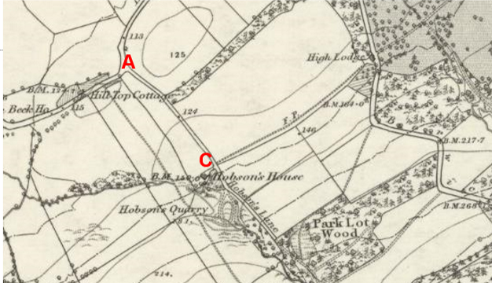
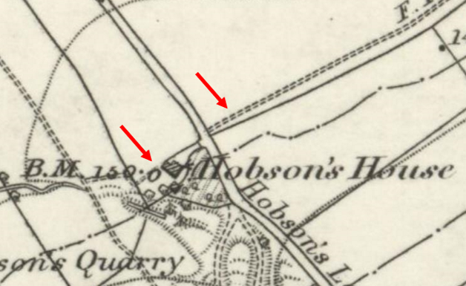
Observations |  | The application route is shown as part of a longer substantial fenced route providing access to Hobson's House, Hobson's quarry and Park Lot Wood. In the same way as it is shown on the larger scale 25 inch OS map detailed above.
Investigating Officer's Comments |  | This map was submitted along with many others by the applicant who considered that it showed the footpath from High Lodge (1-24-FP 15) terminating on Hobson's Lane with the inference that it would then have been necessary to walk along Hobson's Lane (and depending on the direction taken - the application route).  On close examination of the map, and recognising that it was produced as a result of the same survey (1890) as the 25 inch OS map detailed above, the map does show a route crossing Hobson's Lane and continuing west to meet the path shown starting on Capernwray Road and continuing around the quarry.  The 6 inch OS confirms the existence of the application route as part of a substantial bounded track which appeared capable of being used. It does not however appear that it would be necessary to have used the route on foot to get to Capernwray Road as an alternative route – marked on the map as a footpath was shown.
1 inch OS Map  Sheet 49  Kirby Lonsdale | 1898 | 1 inch OS map surveyed 1843-57 and published 1896.
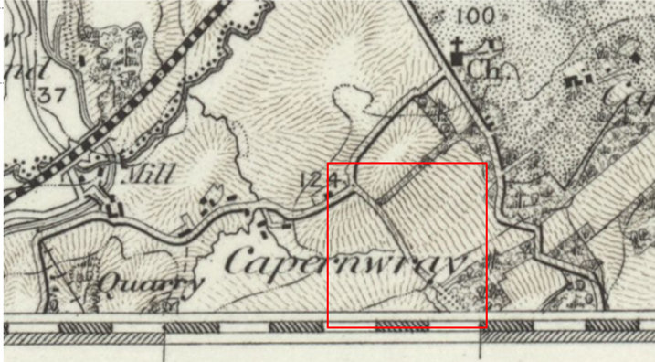
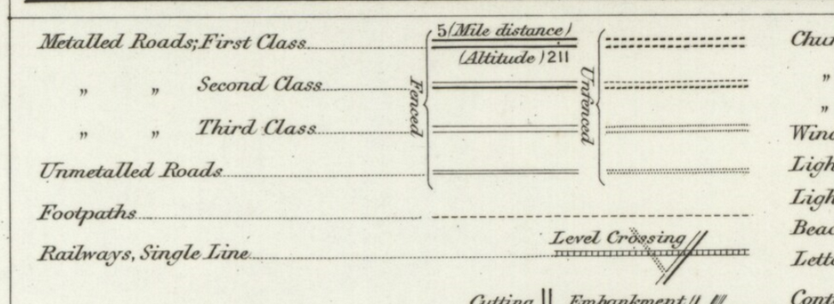
Observations |  | The application route is again shown as part of a longer route leading to an area of woodland.
Investigating Officer's Comments |  | The original scale of the map (1 inch to the mile) means that only the more significant routes are generally shown. The purpose of the map in the late 1800s would probably have been to assist the travelling public on horseback or vehicle suggesting that roads shown were accessible at least on horseback. This is not necessarily an indication of whether use made of the route was public or private.
25 inch OS Map  Sheet XXV.2 | 1913 | Further edition of the 25 inch map surveyed in 1890, revised in 1910 and published in 1913.
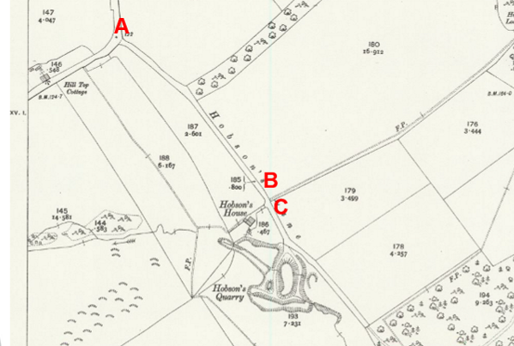
Observations |  | The application route is shown and named as part of Hobson's Lane. The footpath crossing the lane at point C is shown from the east and then passes to the north of Hobson's House to continue around the quarry which is shown as having been extended since the 1890s. The footpath from Capernwray Road which runs parallel to Hobson's Lane to meet the footpath circumnavigating the quarry is also shown.
Investigating Officer's Comments |  | The application route existed in 1910 as part of a longer route which appears to have been capable of being used. A network of routes labelled as footpaths are shown crossing Hobson's Lane and running parallel to it suggesting pedestrian use – whether public or private – was made of these paths. It is not known from looking at the map whether they were used in addition or instead of the application route and continuation of Hobson's Lane.
Bartholomew half inch Mapping | 1902-1906 | The publication of Bartholomew's half inch maps for England and Wales began in 1897 and continued with periodic revisions until 1975. The maps were very popular with the public and sold in their millions, due largely to their accurate road classification and the use of layer colouring to depict contours. The maps were produced primarily for the purpose of driving and cycling and the firm was in competition with the Ordnance Survey, from whose maps Bartholomew's were reduced. An unpublished Ordnance Survey report dated 1914 acknowledged that the road classification on the OS small scale map was inferior to Bartholomew at that time for the use of motorists.
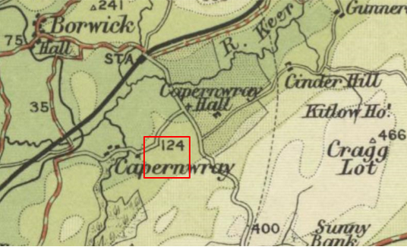
1905
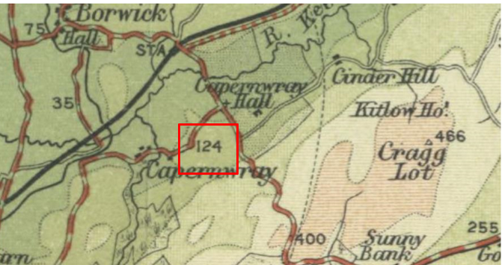
1920
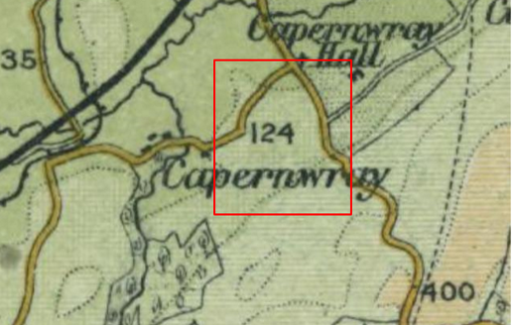
1941
Observations |  | The application route is not shown on any of the three editions of the small-scale Bartholomew's maps published between 1905 and 1941.
Investigating Officer's Comments |  | As Bartholomew's Maps were derived from the Ordnance Survey maps of that time it may be that the route had been purposely omitted by Bartholomew suggesting that if a route did still exist it was not considered to be a significant route at that time and was not considered to be a public vehicular road. It may have been used as a footpath but footpath – and to some extent bridleway – users were not the target customers for these maps so routes used by the public on foot – and possibly horseback – would not necessarily be shown.
Finance Act 1910 Map | 1910 | The comprehensive survey carried out for the Finance Act 1910, later repealed, was for the purposes of land valuation not recording public rights of way but can often provide very good evidence. Making a false claim for a deduction was an offence although a deduction did not have to be claimed so although there was a financial incentive a public right of way did not have to be admitted.  Maps, valuation books and field books produced under the requirements of the 1910 Finance Act have been examined. The Act required all land in private ownership to be recorded so that it could be valued and the owner taxed on any incremental value if the land was subsequently sold. The maps show land divided into parcels on which tax was levied, and accompanying valuation books provide details of the value of each parcel of land, along with the name of the owner and tenant (where applicable).  An owner of land could claim a reduction in tax if his land was crossed by a public right of way and this can be found in the relevant valuation book. However, the exact route of the right of way was not recorded in the book or on the accompanying map. Where only one path was shown by the Ordnance Survey through the landholding, it is likely that the path shown is the one referred to, but we cannot be certain. In the case where many paths are shown, it is not possible to know which path or paths the valuation book entry refers to. It should also be noted that if no reduction was claimed this does not necessarily mean that no right of way existed.  Instructions given to the surveyors at that time said that parcels 'should continue to be exclusive of the site of the external roadways' advising that roadways were routes 'subject to the rights of the public'.  The exclusion of a route may therefore indicate that public use was known but not necessarily vehicular status.  There were however other reasons for a route to be excluded – notably cases of private roads set out in Inclosure Awards with no assigned landownership (shared occupation roads with no single owner).
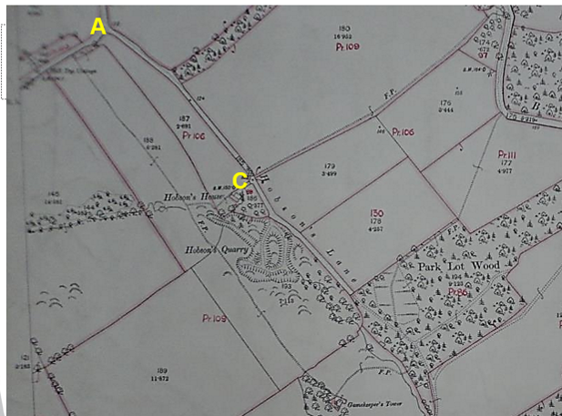
Observations |  | The full length of Hobson's Lane – including the application route – is shown excluded from the numbered plots in the same way that Borron Lane, Capernwray Road and Borwick Road are shown.
Investigating Officer's Comments |  | The map prepared under the provisions of the 1910 Finance Act shows the whole of the route excluded from adjacent land which was acknowledged to be in private ownership.  In this case the application route including the section B-C may have existed in some form prior to inclosure as suggested by its inclusion on Yates' map and the fact that ownership is unknown. In this instance therefore the reason for the exclusion of the route from the taxable hereditaments is uncertain.
6 Inch OS Map  XXVNW | 1916 | Further edition of 6 inch map (surveyed 1844-45, revised in 1910-1911 and published in 1916.
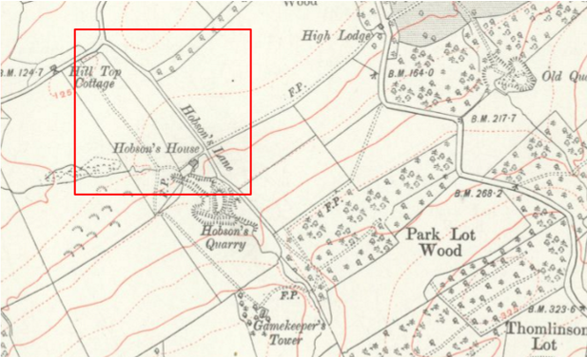
Observations |  | The application route is again shown as part of a longer route (Hobson's Lane) providing access to Hobson's House, a quarry, Gamekeepers Tower and a network of routes marked as footpaths (F.P.s).
Investigating Officer's Comments |  | The application route existed and appeared to be capable of being used in 1910-11.
1932 Rights of Way Map |  | The Rights of Way Act 1932 set out the mechanism by which public rights of way could be established by user and under which landowners could deposit maps to show highways already in existence and to indicate that they didn't intend to dedicate further rights of way. The Commons, Open Spaces and Footpath Preservation Society (which became the Open Spaces Society) who were the prime instigators of this Act and the later 1949 Act, called for local authorities to draw up maps of the public rights of way in existence (a quasi pre-cursor of the Definitive Map). This is set out in 'The Rights of Way Act, 1932. Its History and meaning' by Sir Lawrence Chubb [M]. The process for consultation and scrutiny followed in Lancashire is not recorded but some of the maps exist including maps for the following areas are available for inspection at County Hall: Lunesdale Rural District (RD), Lancaster RD, Burnley RD, Garstang RD and West Lancashire RD.
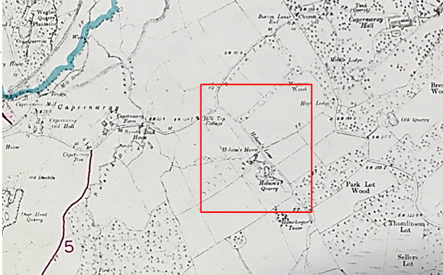
Observations |  | The application route is not shown on the map prepared in 1934 by Lunesdale Rural District Council. The accompanying list of routes is titled as Public Footpaths. 'Parish of Over Kellet. Feb. 1934'. The route recorded as 1-24-FP 15 which crosses Hobson's Lane is not shown either.
Investigating Officer's Comments |  | The application route was not considered by the Rural District Council to be a public footpath in 1934.
6 inch OS Map  Sheet XXV NW | 1934 | Further 6 inch OS map surveyed in 1844-45, revised 1910-1911 and published circa 1934.
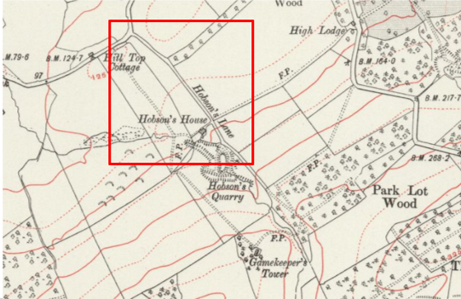
Observations |  | The application route is again shown as part of a longer route (Hobson's Lane) providing access to Hobson's House, a quarry, Gamekeepers Tower and a network of routes marked as footpaths (F.P.s).
Investigating Officer's comments |  | The application route existed and appeared to be capable of being used in 1910-11.
6 inch OS Map  Sheet XXV NW | 1942 | Further 6 inch OS map surveyed in 1844-45, revised 1910-1911 and published circa 1942.
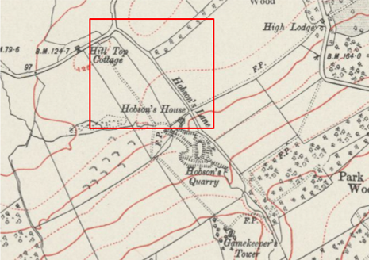
Observations |  | The application route is shown in the same way as it is shown on earlier editions of the ^ inch map detailed above.
Investigating Officer's Comments |  | The application route existed and appeared to be capable of being used in 1910-11.
6 Inch OS Map  Sheet 57SW | 1956 | The OS base map for the Definitive Map, First Review, was published in 1956 at a scale of 6 inches to 1 mile (1:10,560). This map was revised before 1930 and is probably based on the same survey as the 1930s 25-inch map.
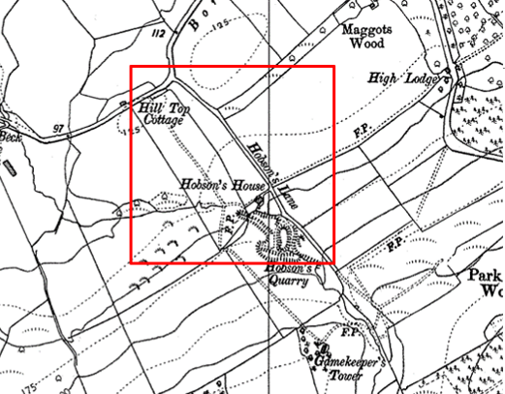
Observations |  | The application route is shown in the same way as it is shown on earlier editions of the 6 inch map detailed above.
Investigating Officer's Comments |  | The application route existed and appeared to be capable of being used in before 1930.
Aerial photograph | 1960s | The black and white aerial photograph taken in the 1960s and available to view on GIS.
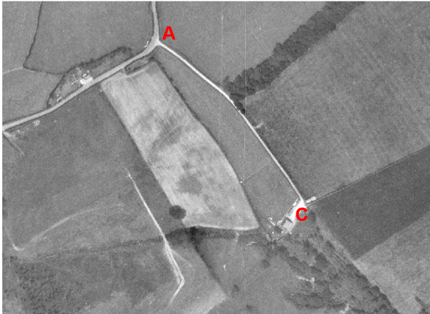
Observations |  | The application route can be clearly seen on the photograph leading to Hobson's House at point C. Beyond point C the lane is barely visible.
Investigating Officer's Comments |  | No inference can be made with regards to the existence of public rights but the aerial photograph supports the existence of the application route existed in the 1960s and appeared to be capable of being used. The way that it is clearly shown suggests regular used by motor vehicles to access Hobson's House.
1:2500 OS Map  SD 5391 7176 and SD 5471 5571 | 1970 | Further edition of 25 inch map reconstituted from former county series and revised in 1969 and published 1971 as national grid series.
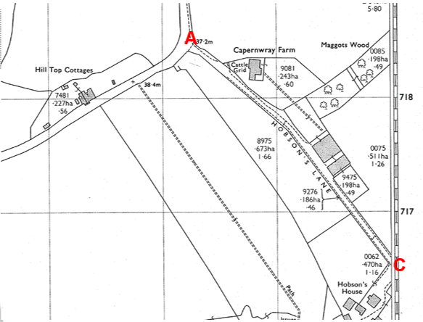
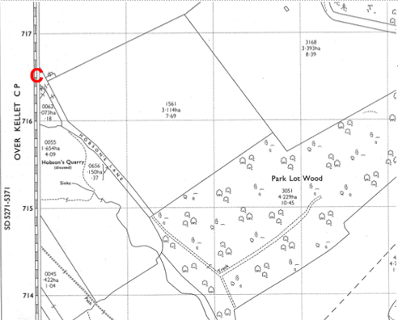
Observations |  | The application route is again shown as part of a substantial bounded route known as Hobson's Lane. Capernwray Farm and two additional large buildings have been built on land to the east of the route and are accessed from it.  A path is still shown running parallel to Hobson's Lane across the adjacent fields which connects to the path recorded as 1-24-FP 15 – which, although only partly shown on the map, crosses Hobson's Lane at point C. Tracks are shown continuing from the south east end of Hobson's Lane into Park Lot Road.
Investigating Officer's Comments |  | The application route existed in 1969 and may have been capable of being used. As is the case with earlier OS maps examined, it is not known from the map whether this use would have been public or private.
Aerial Photograph | 2014 | Aerial photograph available to on GIS.
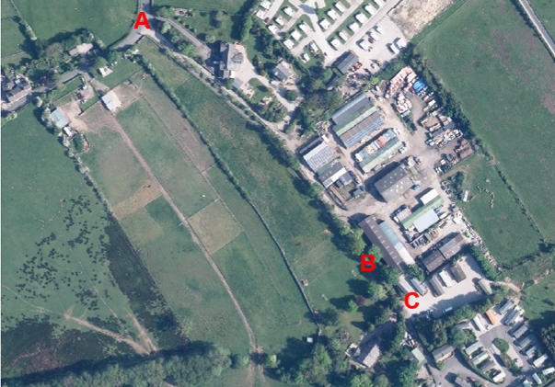
Observations |  | A photograph taken in 2014 shows the extent of development that had taken place in the area surrounding – and accessed by – the application route.  The application route can be seen between point A and point B although access through to point C is obscured by trees. The access road running parallel to the application route can also be seen.
Investigating Officer's Comments |  | The application route existed in 2014 and appeared to have been capable of being used. As is the case with earlier aerial photograph examined, it is not known from the photograph whether this use would have been public or private.
Definitive Map Records |  | The National Parks and Access to the Countryside Act 1949 required the County Council to prepare a Definitive Map and Statement of Public Rights of Way.  Records were searched in the Lancashire Records Office to find any correspondence concerning the preparation of the Definitive Map in the early 1950s.
Parish Survey Map | 1950-1952 | The initial survey of public rights of way was carried out by the parish council in those areas formerly comprising a rural district council area and by an urban district or municipal borough council in their respective areas. Following completion of the survey the maps and schedules were submitted to the County Council. In the case of municipal boroughs and urban districts the map and schedule produced, was used, without alteration, as the Draft Map and Statement. In the case of parish council survey maps, the information contained therein was reproduced by the County Council on maps covering the whole of a rural district council area. Survey cards, often containing considerable detail exist for most parishes but not for unparished areas.
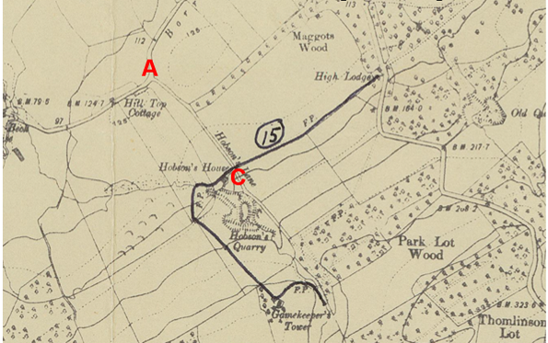
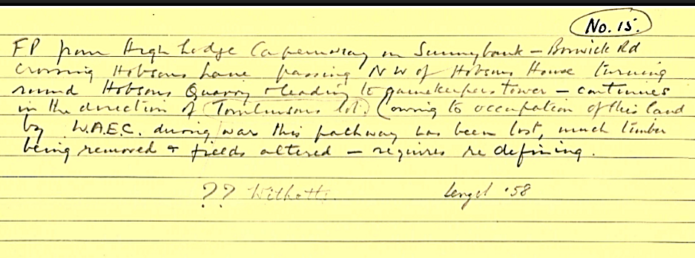
Observations |  | The application route was not recorded on the Parish Survey Map by Over Kellet Parish Council. The footpath numbered as Footpath 15 was described as crossing Hobson's Lane.
Investigating Officer's Comments |  | The Parish Council did not consider that the application route was a route which should be recorded on the Definitive Map and Statement in 1958.  In addition, it appears that there was no indication that the Parish Council considered that Hobson's Lane was a public road. The Footpath was described as crossing Hobson's Lane and given one number (15). Normally, paths were numbered from the junction with one public highway with another so it would have been more likely to see this path numbered – and described as two separate paths if Hobson's Lane was considered to be a public road.
Draft Map |  | The parish survey map and cards for Over Kellet were handed to Lancashire County Council who then considered the information and prepared the Draft Map and Statement.  The Draft Maps were given a “relevant date” (1st January 1953) and notice was published that the draft map for Lancashire had been prepared. The draft map was placed on deposit for a minimum period of 4 months on 1st January 1955 for the public, including landowners, to inspect them and report any omissions or other mistakes. Hearings were held into these objections, and recommendations made to accept or reject them on the evidence presented.
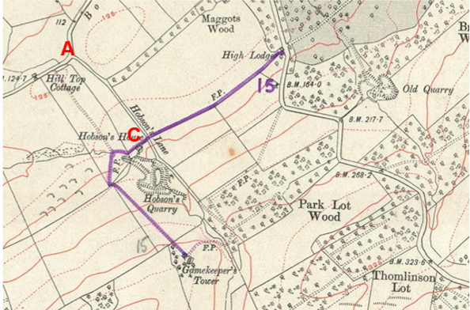
Observations |  | The application route was not shown on the Draft Map and there were no representations or objections to what was shown or omitted.  The route of Footpath 15 was shortened and shown to terminate at the Gamekeeper's Tower.
Provisional Map |  | Once all representations relating to the publication of the draft map were resolved, the amended Draft Map became the Provisional Map which was published in 1960 and was available for 28 days for inspection. At this stage, only landowners, lessees and tenants could apply for amendments to the map, but the public could not. Objections by this stage had to be made to the Crown Court.
Observations |  | The application route was not shown on the Provisional Map and there were no representations or objections to what was shown or omitted.
The First Definitive Map and Statement |  | The Provisional Map, as amended, was published as the Definitive Map in 1962.
Observations |  | The application route was not shown on the First Definitive Map.
Revised Definitive Map of Public Rights of Way (First Review) |  | Legislation required that the Definitive Map be reviewed, and legal changes such as diversion orders, extinguishment orders and creation orders be incorporated into a Definitive Map First Review. On 25th April 1975 (except in small areas of the County) the Revised Definitive Map of Public Rights of Way (First Review) was published with a relevant date of 1st September 1966. No further reviews of the Definitive Map have been carried out. However, since the coming into operation of the Wildlife and Countryside Act 1981, the Definitive Map has been subject to a continuous review process.
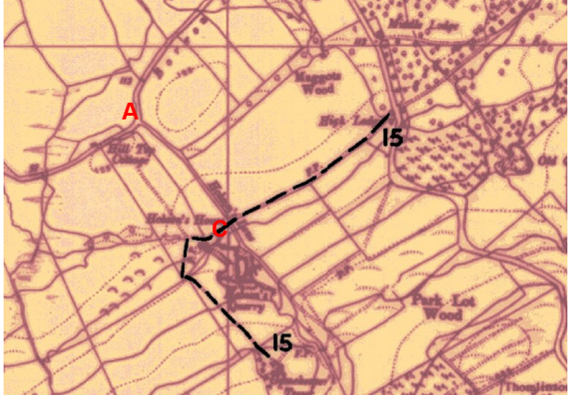
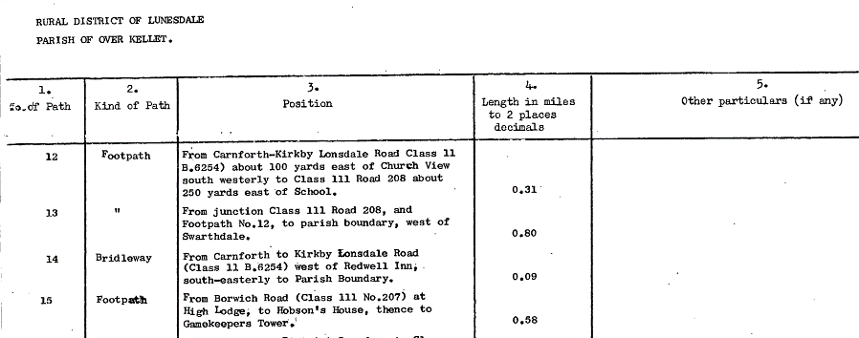
Observations |  | The application route is not shown.
Investigating Officer's Comments |  | From 1953 through to 1975 there is no indication that the application route was considered to be a public right of way which should be recorded on the Definitive Map by the Surveying Authority. There were no objections or representations made regarding the route from the public when the maps were placed on deposit for inspection at any stage of the preparation of the Definitive Map.
Definitive Map Modification Order Application | 1983 | Application submitted on 20th July 1983 by Over Kellet Parish Council to record a footpath running parallel to A-B-C from a point on 1-24-FP 15 near Hobson's House to Borrans Lane.
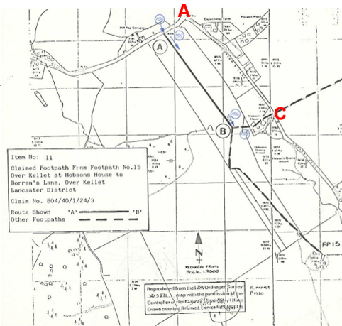
Observations |  | In 1983 Over Kellet Parish Council submitted a number of applications to record additional routes as public rights of way on the Definitive Map and Statement. They did not submit an application to record the application route but they did, however submit an application to record the route shown on many of the OS maps detailed earlier in this report which ran across the field parallel to the application route from Capernwray Road to a junction with 1-24-FP 15.  The application was one of the very first to be received by the County Council following implementation of the Wildlife and Countryside Act 1981. It was based on very limited evidence and was rejected by the County Council's Public Rights of Way Sub Committee at that time.  A newspaper article found on the Public Rights of Way parish files explained that although the parish council believed that the route was a public footpath they had decided not to appeal the decision of the County Council due to a lack of available evidence.  No reference to the application route was found as part of the investigation carried out.
Investigating Officer's Comments |  | Given the number of applications submitted by the parish council at that time, it appears that the application route was possibly not considered to be a public right of way that should be recorded on the Definitive Map and Statement at that time.  The amount of information available and expertise in researching the existence of public rights has greatly developed since the early 1980s suggesting that additional information may have been sought if the application was being investigated now.
Highways Act 1980 Public Path Diversion Order | 2007 | Order made and confirmed by Lancashire County Council in 2007.
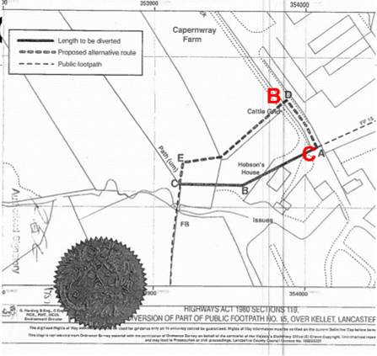
Observations |  | In 2007 the County Council made an Order at the request of the owners of Hobson's House to legally divert 1-24-FP 15 away from their property. The alternative route agreed ran along Hobson's Lane between points B-C on the Committee plan. The Order was confirmed recording a public right of way on foot between point B and point C. A search of the county council's public rights of way files was made but no reference was found to any existing public rights existing – or believed to be in existence – along the application route.
Investigating Officer's Comments |  | The application being considered by the County Council is for a Footpath between point A and point B on the Committee plan. As a public right of way was recorded as a result of the 2007 Diversion Order between point B and point C it is not necessary to include this section of the route in a Definitive Map Modification Order unless it was considered that the evidence suggested the existence of higher public rights (bridleway or vehicular) along the route A-C.
Highway Adoption Records including maps derived from the '1929 Handover Maps' | 1929 to present day | In 1929 the responsibility for district highways passed from district and borough councils to the County Council. For the purposes of the transfer, public highway 'handover' maps were drawn up to identify all of the public highways within the county. These were based on existing Ordnance Survey maps and edited to mark those routes that were public. However, they suffered from several flaws – most particularly, if a right of way was not surfaced it was often not recorded.  A right of way marked on the map is good evidence but many public highways that existed both before and after the handover are not marked. In addition, the handover maps did not have the benefit of any sort of public consultation or scrutiny which may have picked up mistakes or omissions.  The County Council is now required to maintain, under section 31 of the Highways Act 1980, an up to date List of Streets showing which 'streets' are maintained at the public's expense. Whether a road is maintainable at public expense or not does not determine whether it is a highway or not.
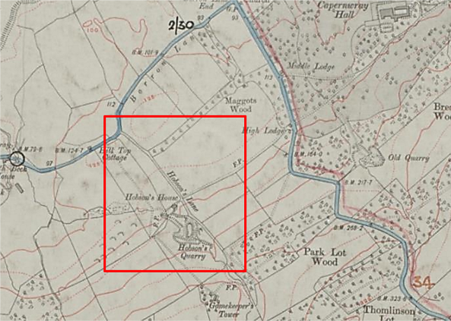
Observations |  | The application route is not recorded as being a publicly maintainable highway.
Investigating Officer's Comments |  | The fact that the application route is not recorded as a publicly maintainable highway does not mean that it does not carry public rights of way.
Highway Stopping Up Orders | 1835 - 2014 | Details of diversion and stopping up orders made by the Justices of the Peace and later by the Magistrates Court are held at the County Records Office from 1835 through to the 1960s. Further records held at the County Records Office contain highway orders made by Districts and the County Council since that date.
Observations |  | No legal orders relating to the creation, diversion or extinguishment of public rights have been found other than the diversion order detailed above.
Investigating Officer's Comments |  | If public rights are found to exist along the application route they do not appear to have been subsequently diverted or extinguished by a legal order.
Statutory deposit and declaration made under section 31(6) Highways Act 1980 |  | The owner of land may at any time deposit with the County Council a map and statement indicating what (if any) ways over the land he admits to having been dedicated as highways. A statutory declaration may then be made by that landowner or by his successors in title within ten years from the date of the deposit (or within ten years from the date on which any previous declaration was last lodged) affording protection to a landowner against a claim being made for a public right of way on the basis of future use (always provided that there is no other evidence of an intention to dedicate a public right of way).  Depositing a map, statement and declaration does not take away any rights which have already been established through past use. However, depositing the documents will immediately fix a point at which any unacknowledged rights are brought into question. The onus will then be on anyone claiming that a right of way exists to demonstrate that it has already been established. Under deemed statutory dedication the 20 year period would thus be counted back from the date of the declaration (or from any earlier act that effectively brought the status of the route into question).
Observations |  | No Highways Act 1980 Section 31(6) deposits have been lodged with the County Council for the area over which the application route runs.
Investigating Officer's Comments |  | There is no indication by the landowners under this provision of non-intention to dedicate public rights of way over this land.

The affected land is not designated as access land under the Countryside and Rights of Way Act 2000 and is not registered common land.

Summary

It is rare to find one single piece of map or documentary evidence which is strong enough to conclude that public rights exist and it is often the case that we need to examine a body of evidence, often spanning a substantial period of time, from which public rights can be inferred.

The application is for public footpath and as such it would not be necessarily expected that it would be shown on any of the small scale early commercial maps. However, in this particular case the route is shown on Yates' Map of 1786 and is shown consistent with how routes now forming part of the general road network are shown.

The route was, however shown by Yates as leading to a dead end casting doubt on whether it would have been used as a public vehicular route at that time.

Of significance is the fact that the route – or one from which the application route appears to have derived - is then shown on an Inclosure Map dated 1805 and is described as a private road. It is not entirely clear whether the application route (in some form) existed prior to the inclosure of the land – at least to point C – but the Inclosure Map and Award do indicate that it was not considered to be a public route at that time.

The later commercial maps published by Greenwood in 1818 and Hennet in 1830 again show the application route and the extension of the route past Hobson's House providing access to some open land – but not as a through route.

Whilst the application route may have been accessible on foot in the 1700s and early 1800s, its inclusion on these early maps it is not considered sufficiently indicative of a route considered to be a public highway at that time - particularly with reference to the creation of a private road – albeit possibly south of point C – in the Inclosure Award and Map.

The Tithe Map prepared in 1840 shows that the application route existed as part of a longer route providing access to Hobson's House and land in private ownership. Access may have been available to the public but there is no indication that any through routes – on foot, or otherwise existed at that time and the Tithe Award provided no useful information regarding which routes shown on the map were considered to be public roads or whether they carried any other type of public rights.

From the 1840s onwards the application route is consistently shown on all OS maps examined as part of a substantial bounded route named on the larger scaled maps as Hobson's Lane which appeared to be accessible – certainly on foot.

With regards to its inclusion on the Ordnance Survey maps, it has generally been considered that OS maps show the physical situation at the time of the survey without regard for whether they had public rights, although there was no disclaimer prior to 1888. Despite this there is now a growing awareness by academics that by the end of the 19th Century the Ordnance Survey were selling large numbers of maps to members of the public and promoting the advantages in finding ways that they could travel in unfamiliar areas, which does have the implication that those routes depicted – particularly through routes - were likely to be public to some extent. However, it remains the case that the main inference from these maps in this particular case is the existence of a route providing access to and from Hobson's House, Hobson's quarry and to privately owned woodland and a Gamekeepers Tower.

Whilst the OS maps clearly show that the route existed they also show that other routes – marked as footpaths (F.P's) ran adjacent to the route and crossed the route providing a network of linking paths which could be used without requiring the use of the application route.

More recent evidence from the 1950s suggests that when the Definitive Map and Statement of Public Rights of Way were being prepared the application route was not recorded and more significantly the route recorded as 1-24-FP 15 was shown – and described – as crossing Hobson's Lane – with no apparent recognition that Hobson's Lane was a public route that did not need to be recorded on the Definitive Map and Statement.

User evidence was not submitted as part of the application and no evidence of historical use by the public was found as part of this investigation. The route was not recorded as a public right of way as part of the Definitive Map process and historically the land crossed by the application route was access to a house, quarry and Gamekeepers Tower.

Whilst the site evidence concurs with the fact that the route could have been used by the public on foot no historical or modern day evidence suggesting such use has been submitted.

In conclusion, a range of OS, commercial maps and other documents were examined which seem to suggest that the route probably came into existence to provide access to and from Hobson's House which was subsequently extended as a private road to access inclosed land.

It was shown excluded as part of the Finance Act valuation in the early 1900s but this piece of evidence seems at odds with other evidence examined and insufficient on its own to infer public rights.

Taking all the evidence into consideration it appears that a route probably existed as since the late 1700s and that it may have been capable of being used by the public but that there is insufficient evidence available from which to deduce that public footpath rights existed.

Head of Service – Legal and Democratic Services Observations

Landownership

The entire length of the application route crosses land which is unregistered.

Information from the Applicant

The Applicant provided the documentary evidence listed below, most of which has been discussed above.

- Greenwood Map (1818)
- Hennet Map (1829)
- Ordnance Survey Maps – 6 inch England and Wales (Drawn scale 1:10,560) 1847, 1890, 1910/11 (pub1916) and 1910/11 (pub 1942).
- Ordnance Survey Maps – 25 inch England and Wales (Drawn scale 1:2,500) First Edition 1890 and 1910 Edition.
- Ordnance Survey Maps – 1 inch England and Wales (Drawn scale 1:63,360)
- 1898, 1947 (pub) and 1955 editions.
- Ordnance Survey Maps – 1:25,000 maps of Great Britain
- Pub. 1947 (34/57-A); surveyed/revised 1910-1951, pub 1952 (SD57 (34/57 – B));
- surveyed/revised 1910-1960, pub. 1952, reprint 1961 (SD57 – B/*)
- Evidence from Tithe, Inclosure and Inland Revenue Valuation Records
- Tithe Records, 1840, ref DRB1/118. Tithe map and Apportionments
- Inclosure Records and Award, 1805, ref AE 5/9.
- Inland Revenue Valuation Records – Finance (1908-1910) Act 1910, IR 133/3/44
- Lancashire County Council Road Status Map (MARIO)
- The Gazette – Stopping Up Orders search returning no results
- Parish Survey record card, IC0010240151 for L.1-24-FP15
- Google map of Hobson’s Lane: indicating commercial properties
- Ordnance Survey Maps – 1:25,000 maps of Great Britain
- Aerial Photos of the Applicant Route, 1960s and 2000s
- Record of Gamekeeper's Tower: A Grade II Listed Building in Capernwray, Lancashire
- Recent photographs of the Application Route (2)

The recent photographs of the route are included below.

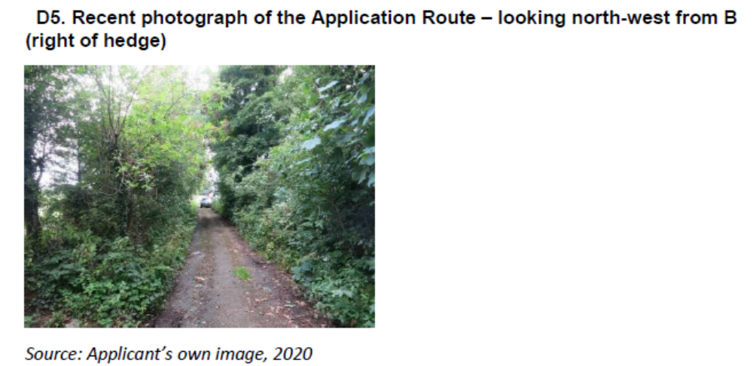

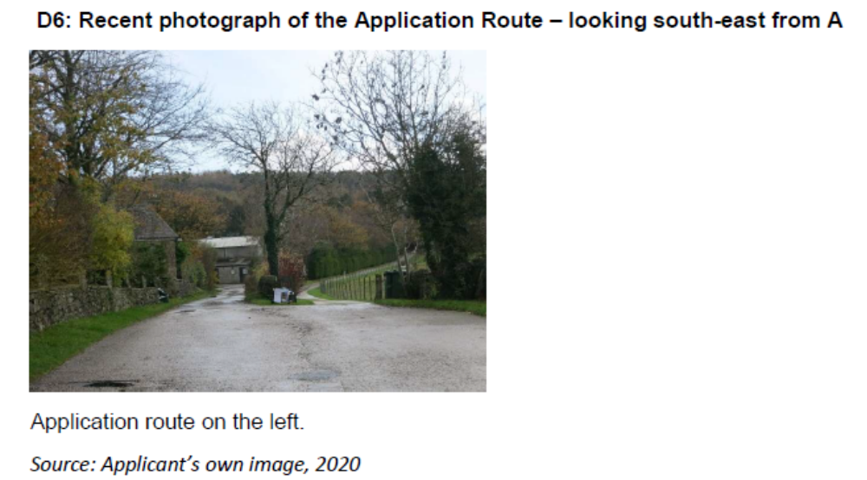

Information from Others

No information was provided by others.

Information from the Landowner

None of the landowners provided a response to consultations.

Assessment of the Evidence

The Law - See Annex 'A'

Insufficient map and documentary evidence to support the presumption of the existence of public rights on the route.

Conclusion

As there is no express dedication and no user evidence forms have been provided in support of this application, it is not possible to satisfy the criteria under s.31 Highways Act 1980 and instead Committee will need to consider on balance whether dedication may be inferred at Common Law.

Committee is therefore advised to consider whether the evidence presented above from the map and other documentary evidence coupled with the evidence on site does on balance indicate that the route should be recorded as a public footpath.

Evidence from the 1805 Inclosure Map and Award suggests the application route or one from which the application route appears to have derived was originally created as a private access route, there is no evidence to suggest public footpath use at this time. The Greenwood's Map of 1818 and the 1830 Hennet's Map of Lancashire later show the route as a "cross road" providing access only to an open space with no through route access, indicating the route continued to be a private access route.

The route is first shown as a through route on the 1847 OS Map and thereafter is consistently shown on all the OS maps examined and referred to as Hobsons Lane. The OS maps clearly show the existence of other surrounding routes marked as footpaths which appear to offer existing convenient public routes available for use instead of the application route.

The Finance Act Map of 1910 shows the application route was excluded, this could be evidence on balance that the route was considered to be public carriageway at that time. However, it is also possible in this case that it was excluding a private joint occupation road not in any particular ownership. The Tithe Map produced in 1840 does not add any further weight and therefore nothing can be inferred about public status from this map.

Significantly when the Definitive Map and Statement of Public Rights of Way were being prepared in the 1950's the application route was not a route recorded as a public footpath despite it appearing to be capable of being used on foot at that time.

Taking all the evidence into account Committee is advised that there is insufficient map and documentary evidence – and no user evidence – and to reject the application and not make an Order adding a public footpath to the Definitive Map and Statement.

Risk management

Consideration has been given to the risk management implications associated with this claim. The Committee is advised that the decision taken must be based solely on the evidence contained within the report, and on the guidance contained both in the report and within Annex 'A' included in the Agenda Papers. Provided any decision is taken strictly in accordance with the above then there is no significant risks associated with the decision making process.

Local Government (Access to Information) Act 1985

List of Background Papers

Paper | Date | Contact/Directorate/Tel
All documents on File Ref: 804-678 |  | Simon Moore, 01772 531280, County Secretary and Solicitors Group
Reason for inclusion in Part II, if appropriate

N/A

The Ordnance Survey (OS) has produced topographic maps at different scales (historically one inch to one mile, six inches to one mile and 1:2500 scale which is approximately 25 inches to one mile). Ordnance Survey mapping began in Lancashire in the late 1830s with the 6-inch maps being published in the 1840s. The large scale 25-inch maps which were first published in the 1890s provide good evidence of the position of routes at the time of survey and of the position of buildings and other structures. They generally do not provide evidence of the legal status of routes, and carry a disclaimer that the depiction of a path or track is no evidence of the existence of a public right of way.

